# Links

<https://www.youtube.com/watch?v=iXYlD_xtQ68&list=PLqz8SLrkjv2iwPtPRJ4V6zJRfgNrgZKlQ&index=1>

# Evolution of the ABAP programming model

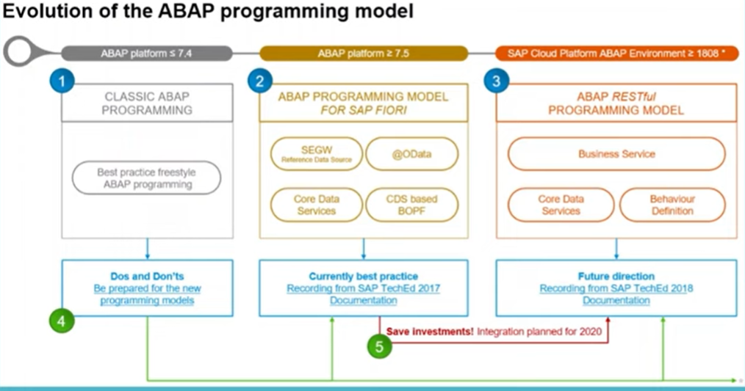

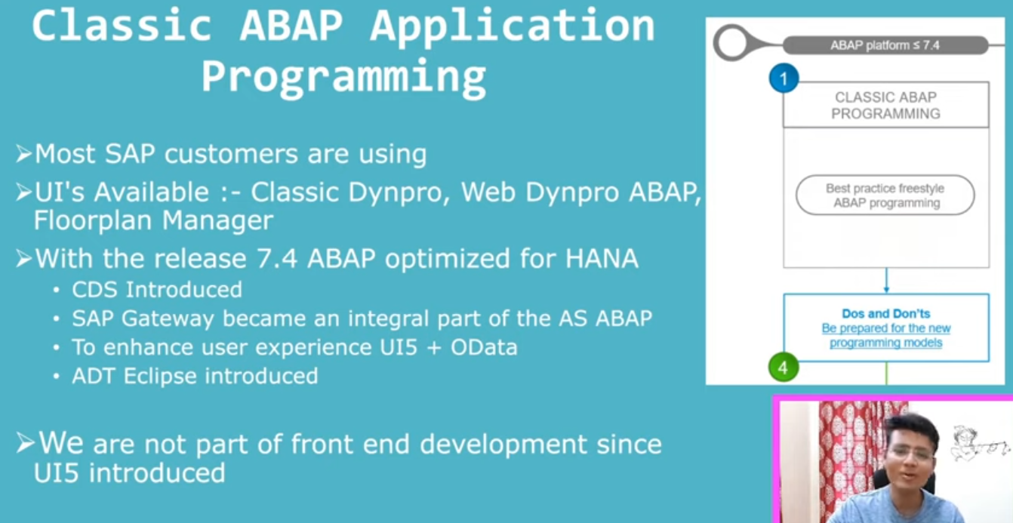

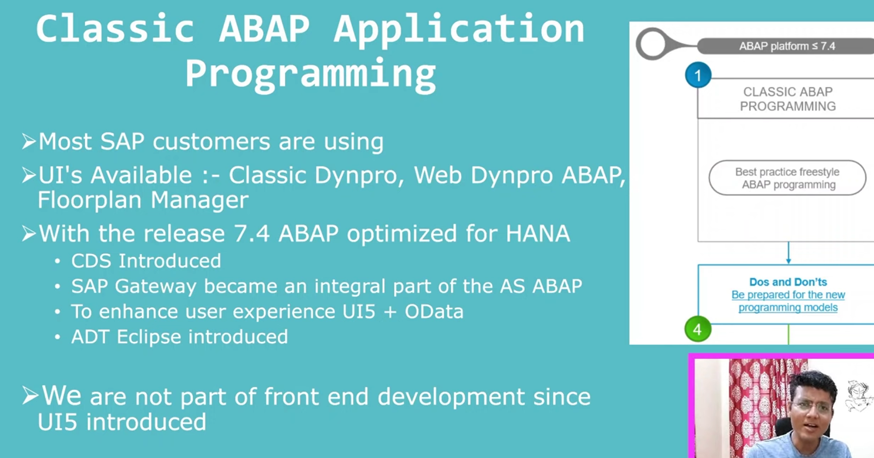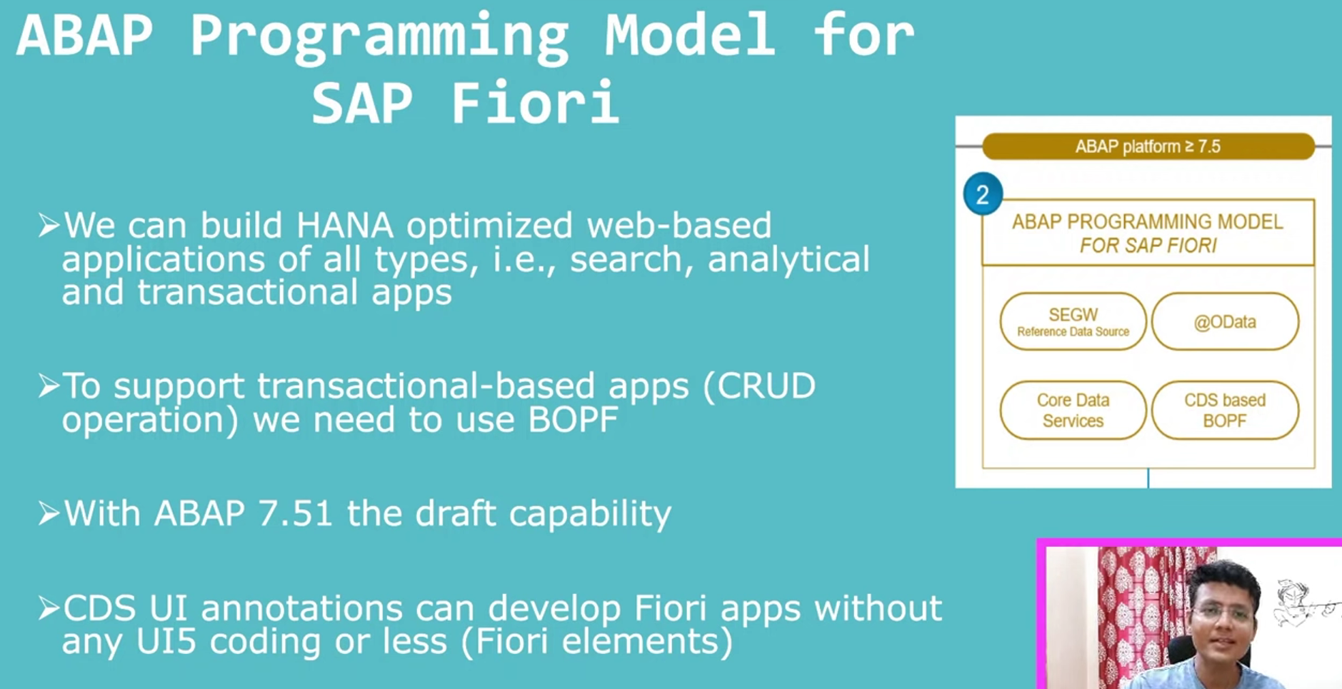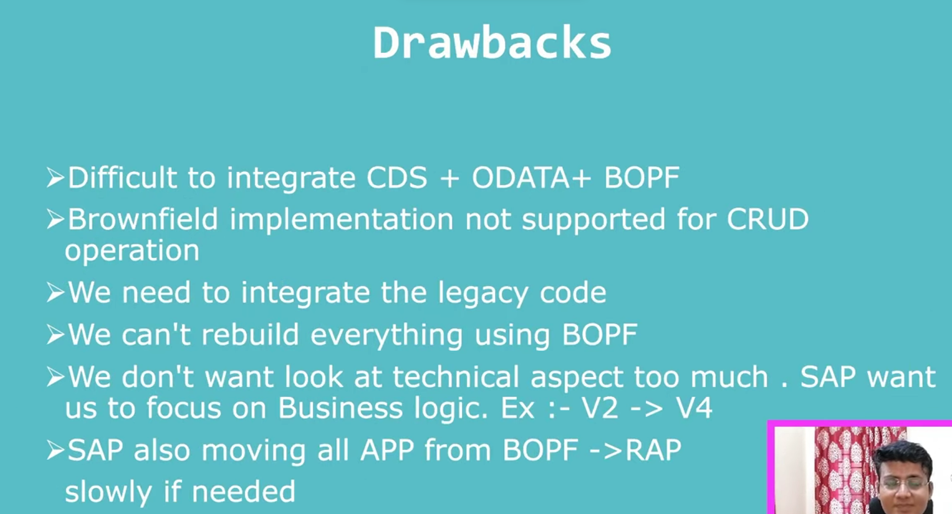

What is greenfield Implementation?- we will not write to any code for create/update/delete, as soon as create the application using BOPF, it will automatically update for you. You are not writing separate code to do the CRUD, so here I am telling these are tables update it backend, it will got updated and deleted and modified whatever want to do.. so this is called green field application.

In BOPF, we are unable to use the legacy code so SAP has implemented RAP to utilize the legacy code also.

In RAP, SAP core concept are remains are same.

